**FORECASTING**

**Business Problem** = ﻿Forecast the cocas Sales data set.

* **Name of the File: -** CocaCola_Sales_Rawdata.xlsx
* **Size of the File: -** 12 KB
* **Necessary Data : -** 42 Observations, 2 Features.

**Exploratory data Analysis** =

* **Dummy Variable: -** Creating 4 Dummy Variables for 4 ﻿Quarter.
* **Missing Value: -** Data don’t have Missing Values
* **Output:** - Forecasted Value.

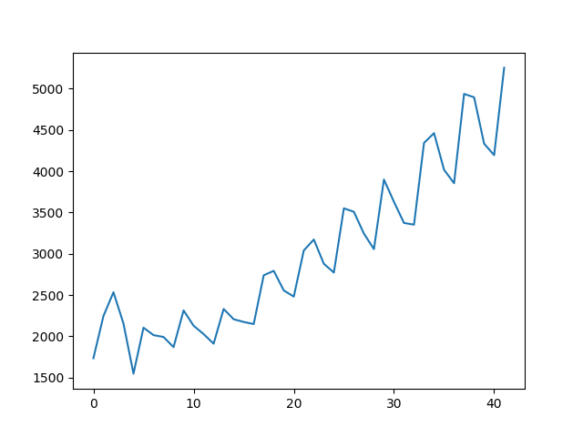**﻿Time Series Plot =**

* **﻿Trend :-** Upward Trend
* **﻿Seasonality :-** Additive Seasonality

**Models Building =** Building Various Regression model and selecting optimized model with low RMSE for the future predication.

|  |  |
| --- | --- |
| **Type of Model** | **RMSE** |
| Linear Model | ﻿﻿591.55 |
| Exponential Model | 466.24 |
| Quadratic Model | 475.56 |
| ﻿Additive seasonality Model | ﻿﻿1860 |
| Additive seasonality Quadratic Trend Model | 302 |
| Multiplicative Seasonality Model | ﻿1963.38 |
| Multiplicative Additive Seasonality Model | ﻿﻿225.52 |

After building various models as shown in the above table with respective RMSE values, the Multiplicative additive Seasonality model has the least RMSE value due to which we use it for Future Predication.

**Python code file**: - [CocaCola Forecasting.py](https://github.com/nilaydeshmukh0/Forecasting/blob/master/CocaCola%20Forecasting/CocaCola%20Forecasting.py)